**SMART INDIA HACKATHON 2022**

**Domain:**

Smart Education

**Problem Title:**

Attendance systems for students of government aided schools.

**Problem Description:**

"Every year number of students take admissions into government aided schools. Currently the attendance system for the students is done manually. Hence requirement of a robust and low-cost system is needed. Addressing this problem will ensure the proper attendance and will help teachers in taking attendance."

**Proposed solution:**

Attendance systems for students of government aided schools.

**Technology Stack:**

* HTML (Hypertext markup language) - This will provide the structure of the website which the browser will show.
* CSS (Cascading style sheet) - This will give style to our website. It will describe how HTML elements should be displayed.
* JavaScript - This programming language will give a way to communicate with computers and tell them what to do. It will give webpages interactive elements that will engage the user.
* Firebase – This will be used to authenticate user’s login. It is also implemented to manage the database.

**Use case:**

A website is typically a collection of web pages, images and other elements that are linked together to form a larger, structured document. Think of a website as a book and each individual Page is a webpage.

First when the website is opened it, a login page appears. After logging in, depending on if the user account is authorized as a coordinator, teacher or student they are taken to their respective home page. The student account will only have the feature of viewing their attendance that they have received in the various subjects they have been registered for. The teacher account will contain a list of all the classes they have been assigned for the semester and their respective routines. On selecting the class, a list of all the students in that class is shown with the button on pressing which the option to record the attendance for the class for a particular day. The controller has number of functions enabled for him as he will be the one who would be responsible for the maintenance and working of the system. The features exclusively enabled for the controller are:

* Adding teacher accounts
* Adding student accounts
* Assigning classes to teachers
* Updating teacher and class routines
* Ratify any correction in already marked attendance

**Use case diagram:**

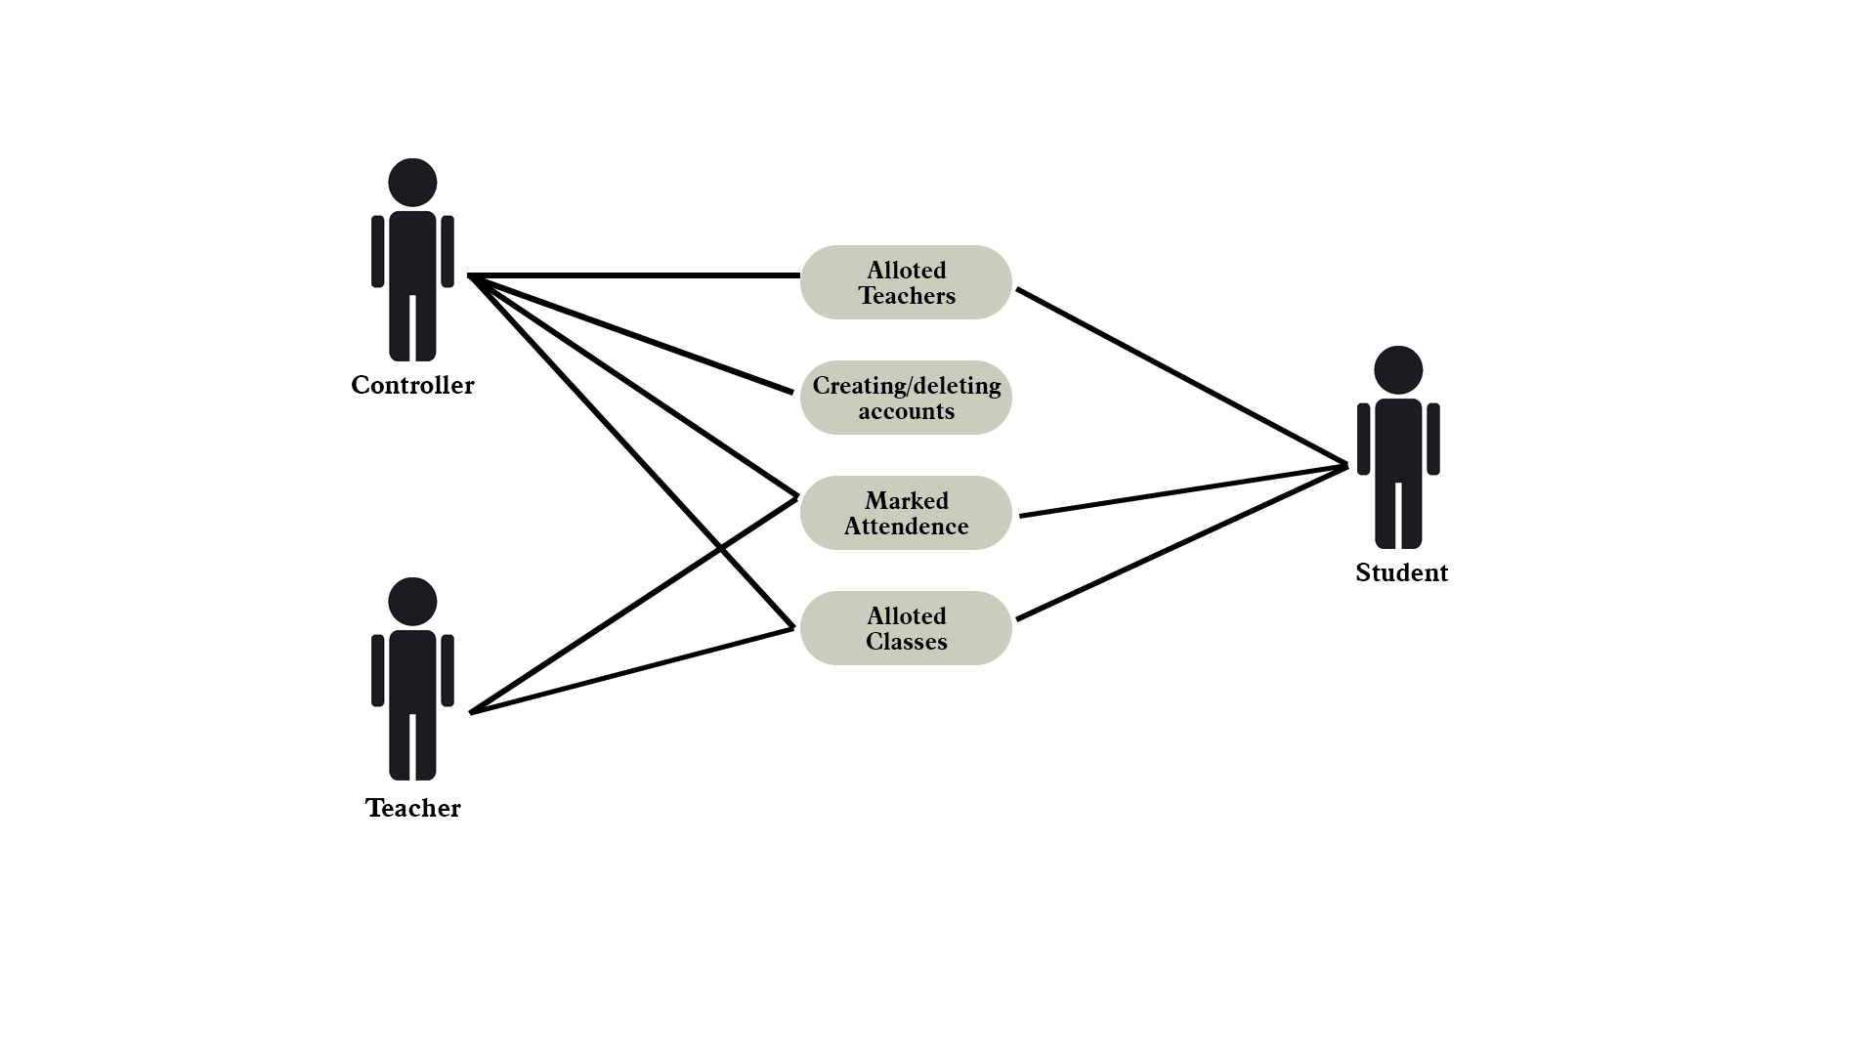

**Team Member Details:**

|  |  |  |  |  |
| --- | --- | --- | --- | --- |
| **Role** | **Name** | **USN** | **Email ID** | **Phone No.** |
| Team Leader | Ritwik Raj | 1SI20IS042 | ritwikraj270@gmail.com | 9102967194 |
| Team Member 1 | Md. Akhtar Ali | 1SI20IS028 | akhtarali2123@gmail.com | 7765826775 |
| Team Member 2 | Avanthi Anil | 1SI20ET007 | avanthitumkur@gmail.com | 78997 95807 |
| Team Member 3 | Vaibhav Singh | 1SI20IS062 | vaibhavmsd39@gmail.com | 9696455572 |
| Team Member 4 | Shreyanshu Shubham | 1SI20IS048 | shreyanshu.dps@gmail.com | 8986496179 |
| Team Member 5 | Rishabh Kanth | 1SI20EC074 | rishabhkanth200@gmail.com | 7665732566 |